Setup Blockchain (Hyperledger) network using docker images

1. Execute following commands to pull docker images required to run Blockchain locally
docker pull hyperledger/fabric-peer
docker pull hyperledger/fabric-membersrvc
docker pull hyperledger/fabric-baseimage:x86_64-0.2.1

2. Change tag of fabric-baseimage to latest.

This is required due to the issue https://jira.hyperledger.org/browse/FAB-300 as a
Workaround

docker tag <image-id> hyperledger/fabric-baseimage:latest

image-id : image id of baseimage can be found by running command “docker
images”

3. Create a directory
e.g mkdir blockchain-compose
cd blockchain-compose

4. Before running the docker-compose up we should have the following command need to be executed on docker if your docker version is greater than 1.12.3

export COMPOSE_CONVERT_WINDOWS_PATHS=1

Note:→ if previously any container id will be there then we have to delete the previous container id by below command

docker rm -f $(docker ps -aq)

5. Create docker-compose.yml file with the below contents

membersrvc:
image: hyperledger/fabric-membersrvc
ports:
- "7054:7054"
command: membersrvc
vp0:
image: hyperledger/fabric-peer
ports:
- "7050:7050"
- "7051:7051"
- "7053:7053"
environment:
- CORE_PEER_ADDRESSAUTODETECT=true
- CORE_VM_ENDPOINT=unix:///var/run/docker.sock
- CORE_LOGGING_LEVEL=DEBUG
- CORE_PEER_ID=vp0
- CORE_PEER_PKI_ECA_PADDR=membersrvc:7054
- CORE_PEER_PKI_TCA_PADDR=membersrvc:7054
- CORE_PEER_PKI_TLSCA_PADDR=membersrvc:7054
- CORE_SECURITY_ENABLED=true
- CORE_SECURITY_ENROLLID=test_vp0
- CORE_SECURITY_ENROLLSECRET=MwYpmSRjupbT
volumes:
- /var/run/docker.sock:/var/run/docker.sock
links:
- membersrvc
command: sh -c "sleep 5; peer node start"

5. Run following command to start the Blockchain network with the images
(More information about docker compose can be found at :
https://docs.docker.com/compose/ )

docker-compose up

Make sure that to errors or failed messages displayed on the screen.

6. You can check running container by executing following command

docker ps –a

You should see 2 containers:

- peer_vp0_1
- peer_membersrvc_1

PORT FORWARDING

Since port mentioned in docker-compose.yml files are not available in windows environment, we need to give the corresponding entry in virtual box for port forwarding.

Open virtual box→settings→networks→advance→Port forwarding.

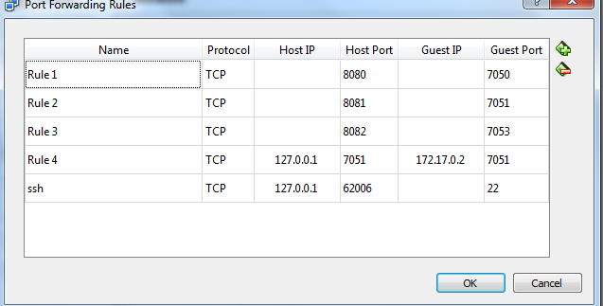

Through REST API

a. Use the IP address printed on Quickstart Docker Terminal (as mentioned in
Section A Step 9) as REST API Endpoint for REST API invocation.
b. Use any REST Client (e.g. REST Client for Firefox or Postman for Chrome)
c. Use the GET call below to make sure REST API endpoint is configured correctly.

http://<IP Address>:8080/network/peers
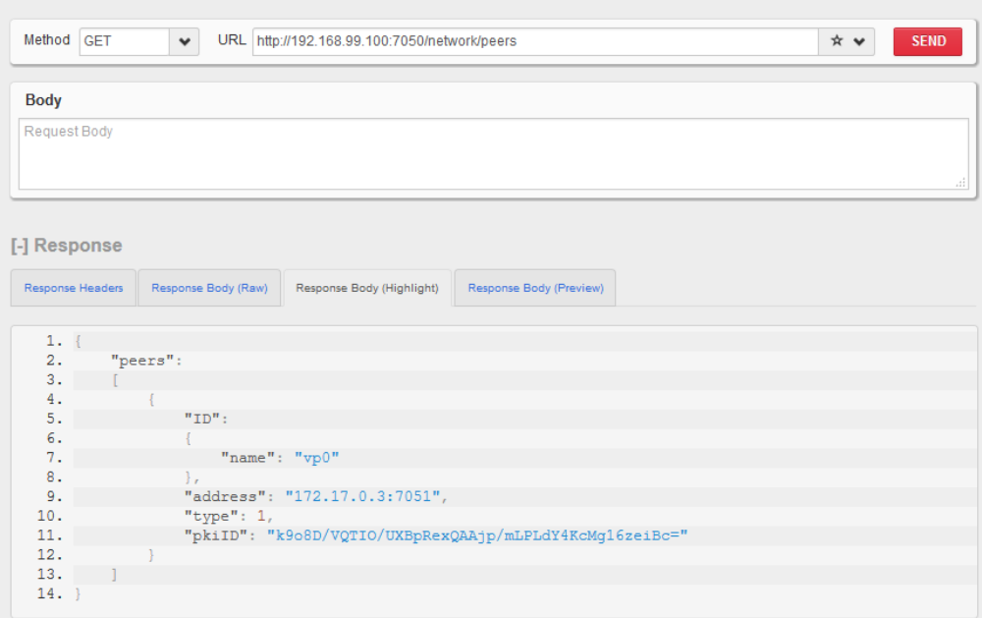

Use POST call to register the User

http://<IP Address>:8080/registrar

with Body as:
{
"enrollId":"test_user0",
"enrollSecret":"MS9qrN8hFjlE"
}

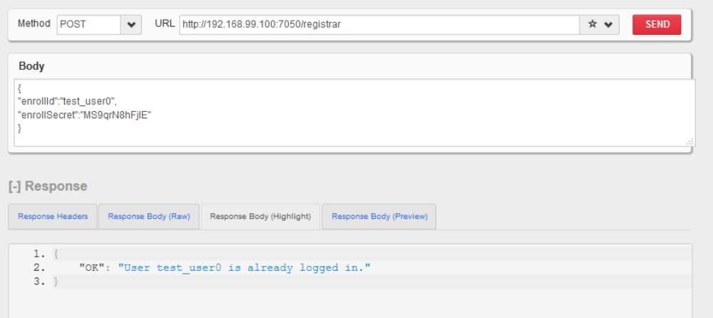

Deploy Chaincode with REST API

http://<IP Address>:8080/chaincode

With Body as:
{
"jsonrpc": "2.0",
"method": "deploy",
"params": {
"type": 1,
"chaincodeID": {
"path":
"github.com/hyperledger/fabric/examples/chaincode/go/chaincode_example02"
},
"ctorMsg": {
"function": "init",
"args": [
"a",
"100",
"b",
"200"
]
},
"secureContext": "test_user0"
},
"id": 1
}
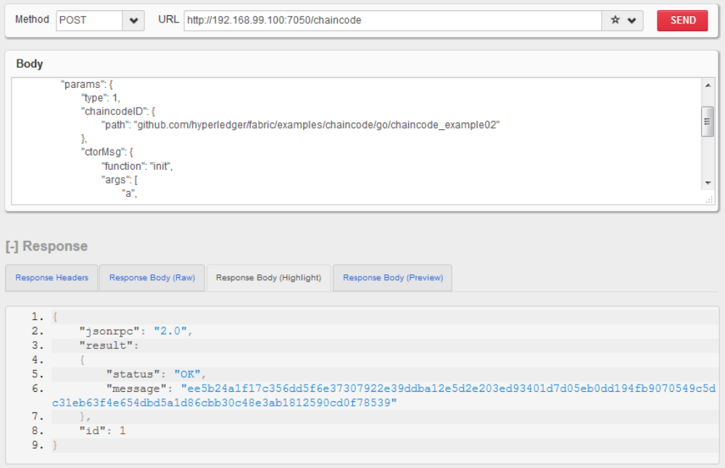

Note:→ please make sure after deploying the chaincode through the rest api as above we should see the 3 container after giving the below command.

docker ps –a

You should see 3 containers:

- peer_vp0_1
- peer_membersrvc_1
- dev-vp0- ee5b24a1f17c356dd5f6e37307922e39ddba12e5d2e203ed93401d7d05eb0dd19 4fb9070549c5dc31eb63f4e654dbd5a1d86cbb30c48e3ab1812590cd0f78539

Invoke Chaincode with REST API

http://<IP Address>:8080/chaincode

With Body as :
{
"jsonrpc": "2.0",
"method": "invoke",
"params": {
"type": 1,
"chaincodeID": {
"name":
"ee5b24a1f17c356dd5f6e37307922e39ddba12e5d2e203ed93401d7d05eb0dd19
4fb9070549c5dc31eb63f4e654dbd5a1d86cbb30c48e3ab1812590cd0f78539"
},
"ctorMsg": {
"function": "invoke",
"args": [
"a",
"b",
"10"
]
},
"secureContext": "test_user0"
},
"id": 2
}

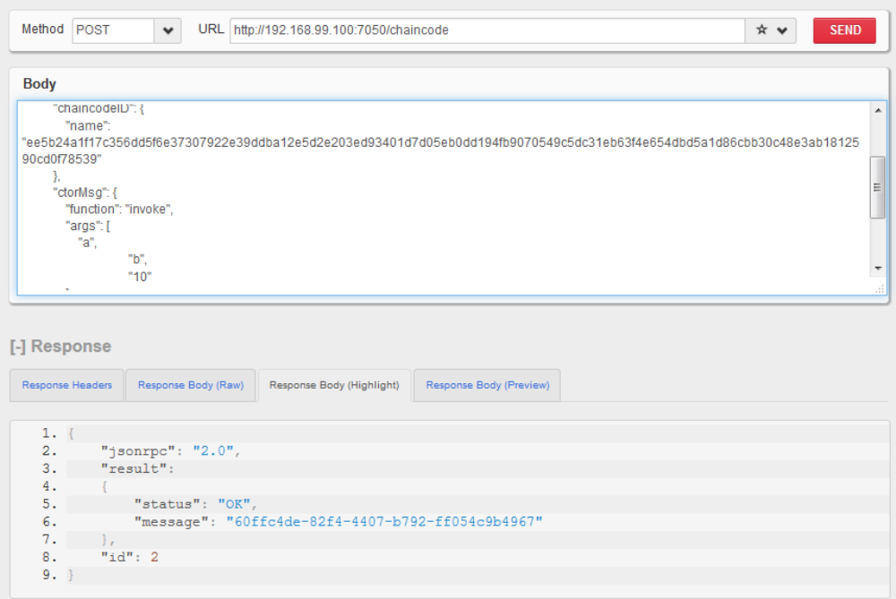

Query Chaincode with REST API

http://192.168.99.100:8080/chaincode

With Body as:
{
"jsonrpc": "2.0",
"method": "query",
"params": {
"type": 1,
"chaincodeID": {
"name":
"ee5b24a1f17c356dd5f6e37307922e39ddba12e5d2e203ed93401d7d05eb0dd19
4fb9070549c5dc31eb63f4e654dbd5a1d86cbb30c48e3ab1812590cd0f78539"
},
"ctorMsg": {
"function": "query",
"args": [
"a"
]
},
"secureContext": "test_user0"
},
"id": 2
}
